Thickness

Definition
# Source: AI Source: Provided by: [Data Path: Persons Table -> ID Column: 1, Name_En Column: Motasem Essam] -> From: [ChatGPT] on [7/17/2026]
Thickness is the measurement of the distance between two opposite surfaces of an object, usually representing its smallest dimension. It describes how thick or thin an object is and is commonly used for flat or hollow objects such as sheets, plates, walls, pipes, and coatings.
Unlike depth, which measures the front-to-back extent of an object, thickness measures the distance through the material itself.

Characteristics
# Source: AI Source: Provided by: [Data Path: Persons Table -> ID Column: 1, Name_En Column: Motasem Essam] -> From: [ChatGPT] on [7/17/2026]
Thickness:
- Measures the distance between two opposite surfaces.
- Usually represents the smallest dimension of an object.
- Is perpendicular to the object's surface.
- Is expressed as a linear measurement.
- Is commonly measured in millimeters or inches for thin objects.

Illustration
# Source: AI Source: Provided by: [Data Path: Persons Table -> ID Column: 1, Name_En Column: Motasem Essam] -> From: [ChatGPT] on [7/17/2026]
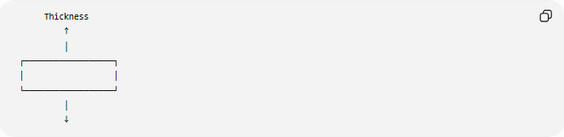
Thickness
↑
│
┌──────────────────┐
│ │
└──────────────────┘
│
↓

Measurement Units
# Source: AI Source: Provided by: [Data Path: Persons Table -> ID Column: 1, Name_En Column: Motasem Essam] -> From: [ChatGPT] on [7/17/2026]
Thickness may be measured using:
Metric Units
- Micrometer (µm)
- Millimeter (mm)
- Centimeter (cm)
- Meter (m)
Imperial Units
- Thousandth of an inch (mil)
- Inch (in)
- Foot (ft)

Measuring Instruments
# Source: AI Source: Provided by: [Data Path: Persons Table -> ID Column: 1, Name_En Column: Motasem Essam] -> From: [ChatGPT] on [7/17/2026]
Common instruments used to measure thickness include:
- Vernier Caliper
- Digital Caliper
- Outside Micrometer
- Thickness Gauge
- Dial Thickness Gauge
- Ultrasonic Thickness Gauge
- Feeler Gauge
- Coordinate Measuring Machine (CMM)

Examples
# Source: AI Source: Provided by: [Data Path: Persons Table -> ID Column: 1, Name_En Column: Motasem Essam] -> From: [ChatGPT] on [7/17/2026]
Thickness can describe the measurement of:
- Paper
- Glass
- Metal sheet
- Wooden board
- Plastic plate
- Wall
- Pipe wall
- Paint coating

Mathematical Representation
# Source: AI Source: Provided by: [Data Path: Persons Table -> ID Column: 1, Name_En Column: Motasem Essam] -> From: [ChatGPT] on [7/17/2026]
Thickness is commonly represented by:
$$t$$
Example:
A steel plate has:
$$t=8\text{ mm}$$

Relationship to Other Dimensions
# Source: AI Source: Provided by: [Data Path: Persons Table -> ID Column: 1, Name_En Column: Motasem Essam] -> From: [ChatGPT] on [7/17/2026]
For a thin rectangular sheet:
- Length
- Width
- Thickness
For a rectangular block:
- Length
- Width
- Height
Thickness is generally used when one dimension is much smaller than the other two.

Applications
# Source: AI Source: Provided by: [Data Path: Persons Table -> ID Column: 1, Name_En Column: Motasem Essam] -> From: [ChatGPT] on [7/17/2026]
Thickness measurement is used in:
- Geometry
- Engineering
- Manufacturing
- Mechanical Design
- Construction
- Quality Control
- Materials Science
- Metal Fabrication
- Coating Inspection
- CAD (Computer-Aided Design)

Advantages
# Source: AI Source: Provided by: [Data Path: Persons Table -> ID Column: 1, Name_En Column: Motasem Essam] -> From: [ChatGPT] on [7/17/2026]
Measuring thickness helps to:
- Verify manufacturing specifications.
- Ensure product quality.
- Determine material strength.
- Inspect coatings and walls.
- Improve precision in engineering and fabrication.

Limitations
# Source: AI Source: Provided by: [Data Path: Persons Table -> ID Column: 1, Name_En Column: Motasem Essam] -> From: [ChatGPT] on [7/17/2026]
Thickness:
- Depends on selecting the correct measuring surfaces.
- May vary across irregular objects.
- Often requires specialized instruments for very thin or thick materials.

Comparison with Other Dimensions
# Source: AI Source: Provided by: [Data Path: Persons Table -> ID Column: 1, Name_En Column: Motasem Essam] -> From: [ChatGPT] on [7/17/2026]
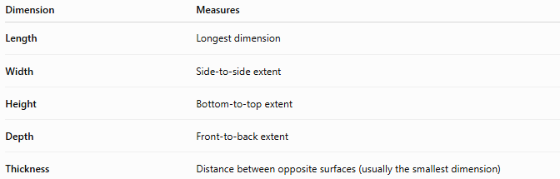
Dimension | Measures
Length | Longest dimension
Width | Side-to-side extent
Height | Bottom-to-top extent
Depth | Front-to-back extent
Thickness | Distance between opposite surfaces (usually the smallest dimension)

Difference Between Thickness and Depth
# Source: AI Source: Provided by: [Data Path: Persons Table -> ID Column: 1, Name_En Column: Motasem Essam] -> From: [ChatGPT] on [7/17/2026]
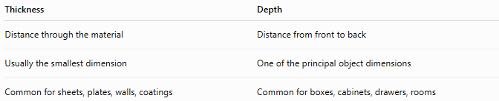
Thickness | Depth
Distance through the material | Distance from front to back
Usually the smallest dimension | One of the principal object dimensions
Common for sheets, plates, walls, coatings | Common for boxes, cabinets, drawers, rooms

Key Points
# Source: AI Source: Provided by: [Data Path: Persons Table -> ID Column: 1, Name_En Column: Motasem Essam] -> From: [ChatGPT] on [7/17/2026]
- Thickness measures the distance between opposite surfaces of an object.
- It is commonly represented by:
$$t$$
- Thickness usually represents the smallest dimension.
- It differs from depth, which measures the front-to-back extent of an object.
- Thickness measurement is widely used in engineering, manufacturing, construction, materials science, and quality control.

Conclusion
# Source: AI Source: Provided by: [Data Path: Persons Table -> ID Column: 1, Name_En Column: Motasem Essam] -> From: [ChatGPT] on [7/17/2026]
Thickness is the measurement of the distance between two opposite surfaces of an object, typically representing its smallest dimension. It is especially important for thin materials such as sheets, plates, coatings, and walls, where material size directly affects strength, performance, and quality. Accurate thickness measurement is fundamental in engineering, manufacturing, construction, materials science, quality control, CAD, and industrial inspection, ensuring that products meet design specifications and safety requirements.

